Changes List

**Application changes**

* Niche na pagema data add kare to te data kya jai che?

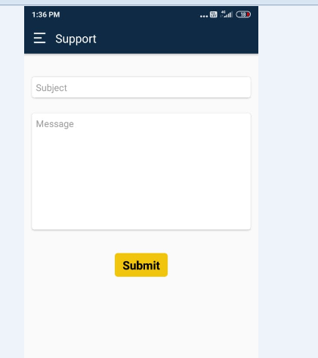

* Niche nu che te Static rakhel che.. pan je te contractors ne Tendor mali gyu hoy te contractors ni company nu name tya aavse.. ( NA KKHYAL AAVE TO EKJE HU EXPLAIN KARISH)

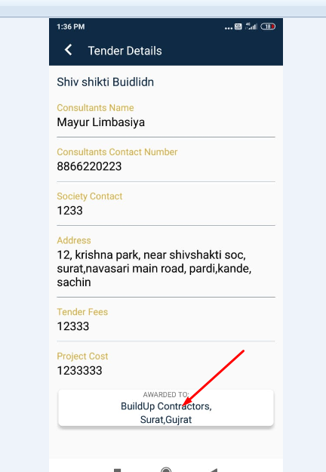

* Niche na ma Badha pages mathi “EMAIL” ne remove karvu and teni baju ma je star che tene pan remove karvu

# Awarded Tendors par click kariye etle Je te contractors hoy tene je tendors malya hoy tenu list tya aavse bija pages ma

“Awred tendors” par click karse etle “Tendors” page ni jevi design che tevij same to same aavse pan tema jete contractors na tendors hase tenuj list aavse badha Tendors nu list nhi aave

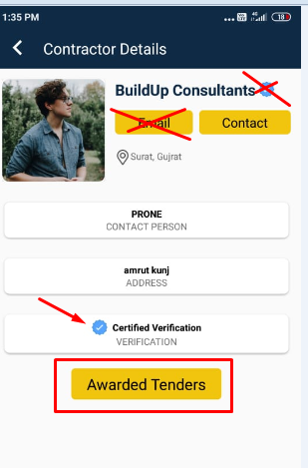

* Badha pages ma aa “Rating” che te static rakhel che k dynamic che?

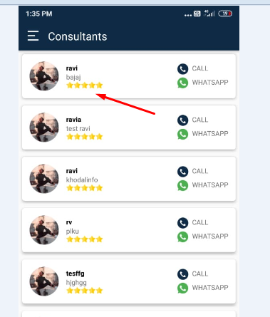

* Profile page ma Je te hoy tenu “Rating” add karvu

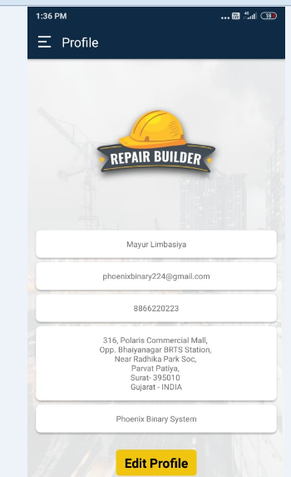

* Notification nu page aa rite aavse.. Mesasage and Date niche. Pan design and fonts tari rite color ne anurup rakhje

