<http://pnxschool.com/repairbuilder/admin>

admin

naren@123

App test karva mate

<https://play.google.com/store/apps/details?id=com.app.repairbuilder_phoenix>

Consultant : 9426857861

Contractor: 9712270223

Vendor : 9913731200

Labour : 8866220223

* Niche nu check karvu

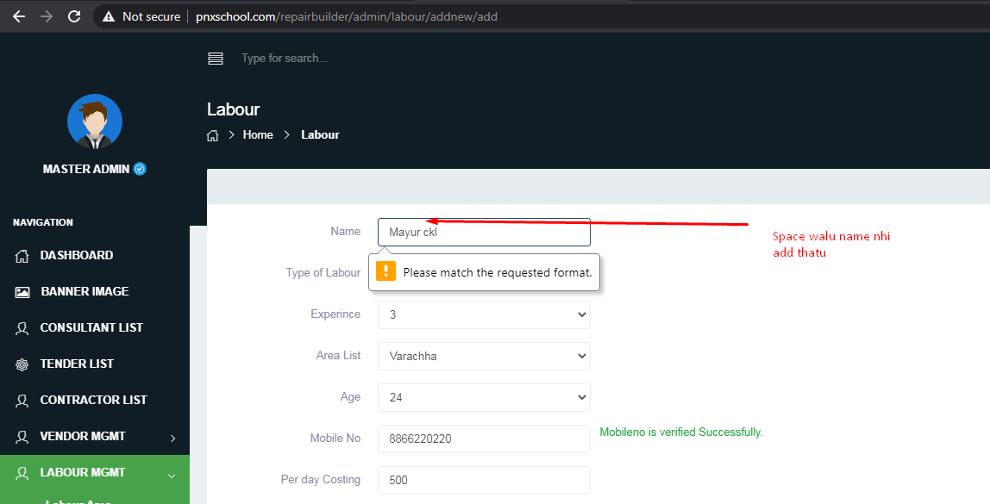

* Niche na page ma Document add karel che to pan app ma show nhi thata..

Consultant, Contractors, Vendor and Labour badha ma PDF add karu 6u to show nhi thtu.

Niche aapel details badha na 1-1 number che.. app ma login kari ne check karvu..Document admin ma add karel hase to pan show nhi that..PDF add karvi.

Consultant : 9426857861

Contractor: 9712270223

Vendor : 9913731200

Labour : 8866220223

* Tendors na je document che te pan show nhi tha..PDF show nhi thtu.. Img upload karel hoy te show thay che
* Contracotrs na admin ma Document pan show nhi thata…aakhi admin ma jya pan document hoy tya badhaj check karva

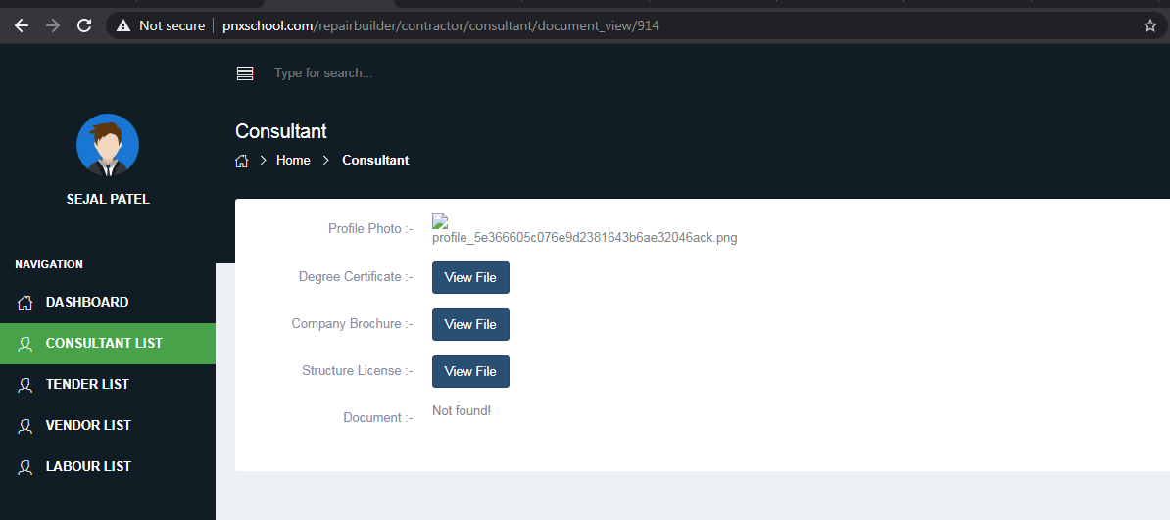

* Aa page ma tender send thay jai che pan koi ne maltu nhi…Testing kari ne check karvu. Na khyal aave to pucvu

<http://pnxschool.com/repairbuilder/consultant/tender/view>

Automatically “Ravi” ne assign thay jai che

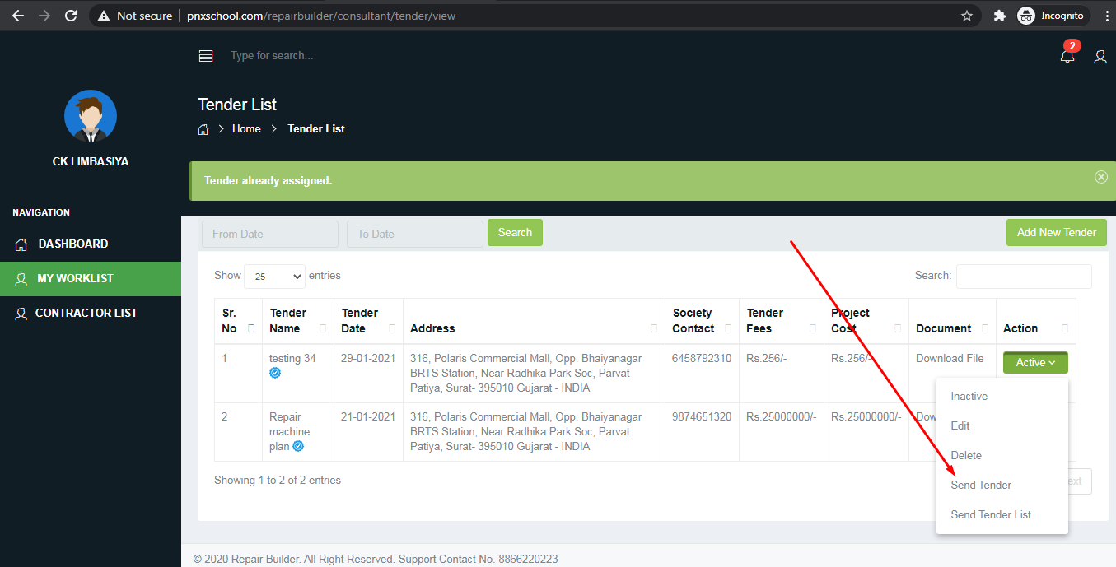

* Upar na badha points thay etle Application ma login vakhate OTP rakhi deje(prashant)