**Change**

* Import excelsheet work nhi karti proper
* Same to same mobile number hoy to pan chalse and email id pan chalse tem karvanu che
* Site ma content change karvanu che (mayur, maheshbhai, punitbhai) mayur karse
* Side bar ma scrool mukvanu che
* Je pan upload karvanu che tya badhaj document upload karva pade tem karvanu che..like PDF, excel, JPG, PNG, docsument file
* App crashed thay che..check karvi
* Niche na page ma Download failed no optioned aave che

<https://capbm.in/client/gst_document/view>

* Niche na page ma “add services” mate ek “Description nu text box rakhvanu che

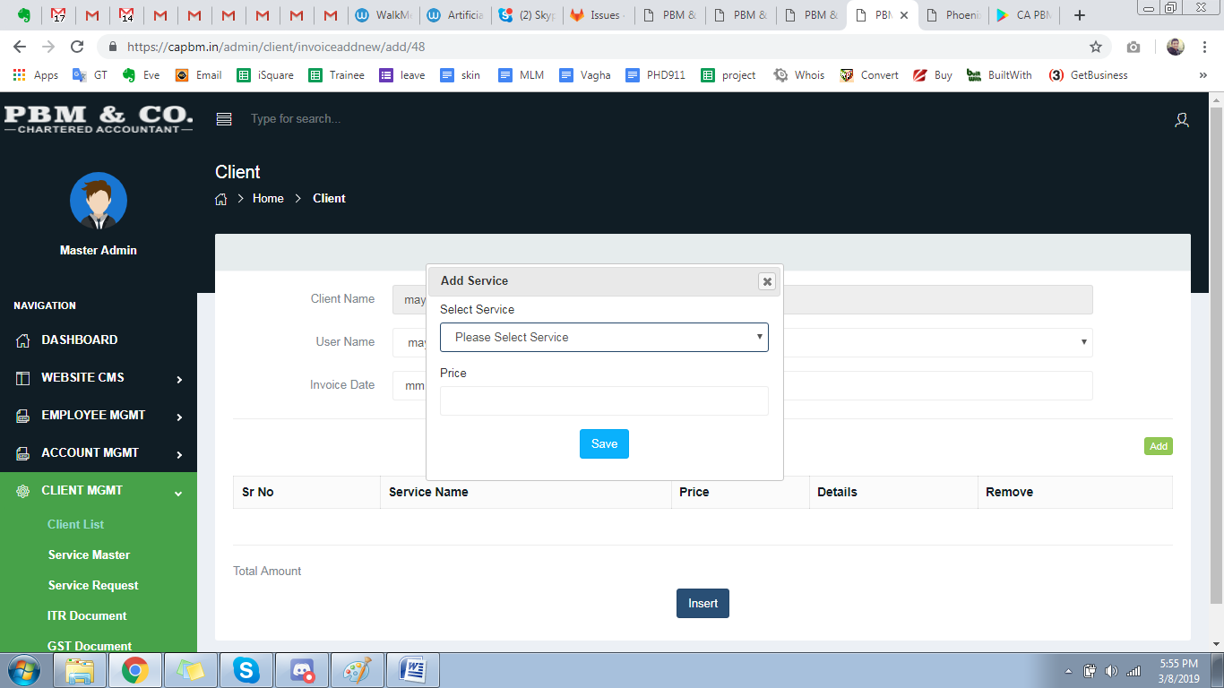

* Admin mathi notification nakhe etle client ni app and admin ma notification upar show thay tem karvanu che (latest upar aave tem karvu)
* Niche na page ma ek sathe file add thay che pan badhi alag alag display thay che..  
  For example: 3 PDF add kari hoy to te download pan ek sathe 3 PDF thavi joiye

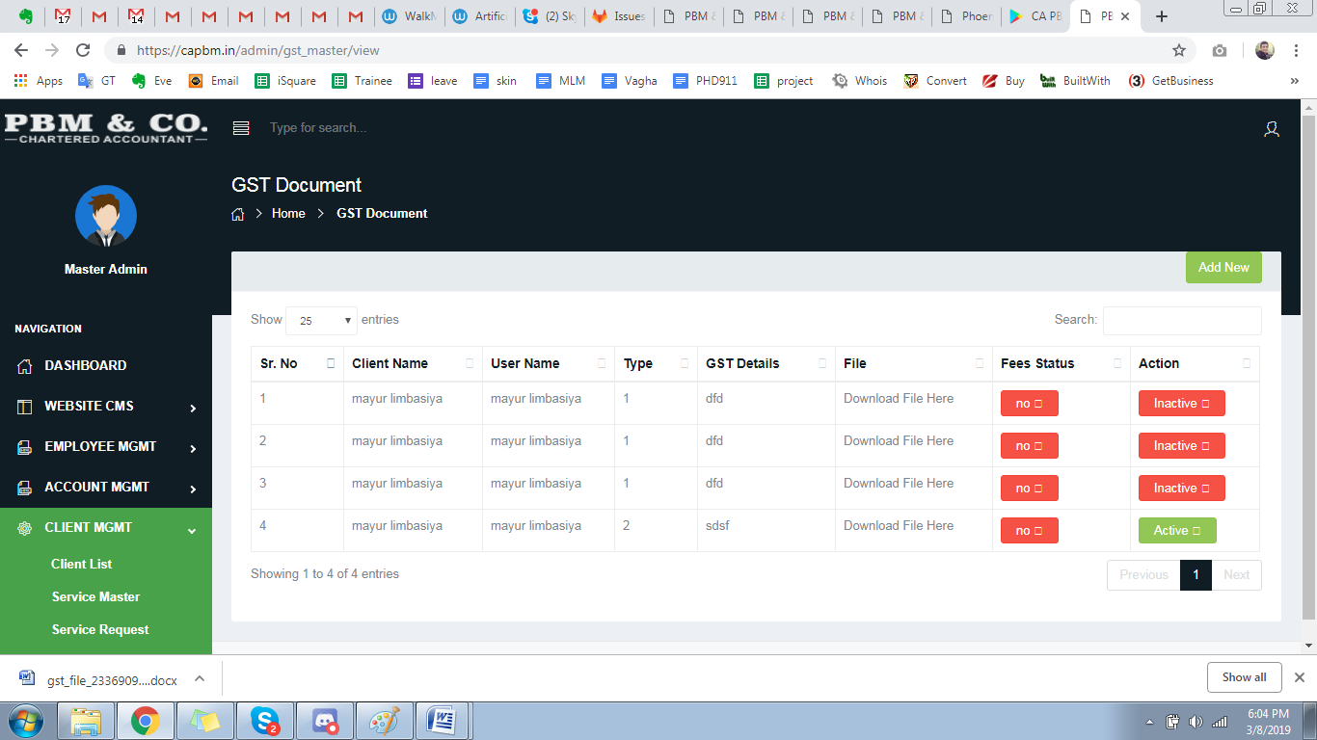

* Niche na page ma “Download YES” kare to te khyal kem aavse ke YES karel che…CA ne khyala ave tena mate kaik table ma show karvu padse

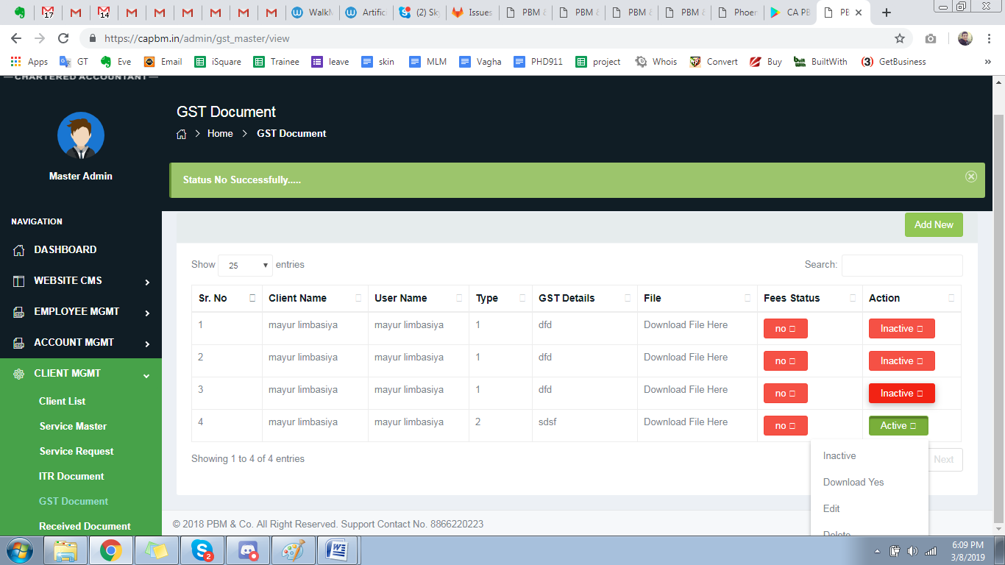

* Niche na page ma Discount no option rakhvano che

For example: 2000 levana che and aapne client ne 400 discount aapvu che to te 1600 cash ma lidha and 400 Discount na textbox ma nakhi didha tem karvanu che

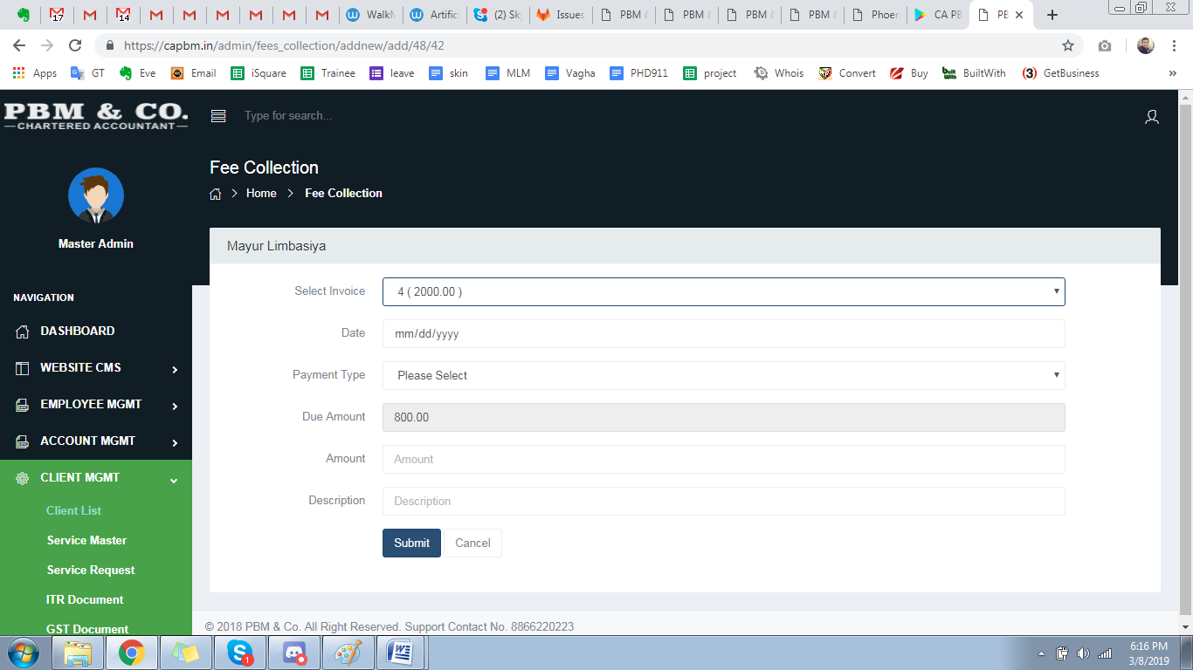

* Niche na page ma income report kadhva mate “Stardt Date” and “End Date” nu button rakhvanu che

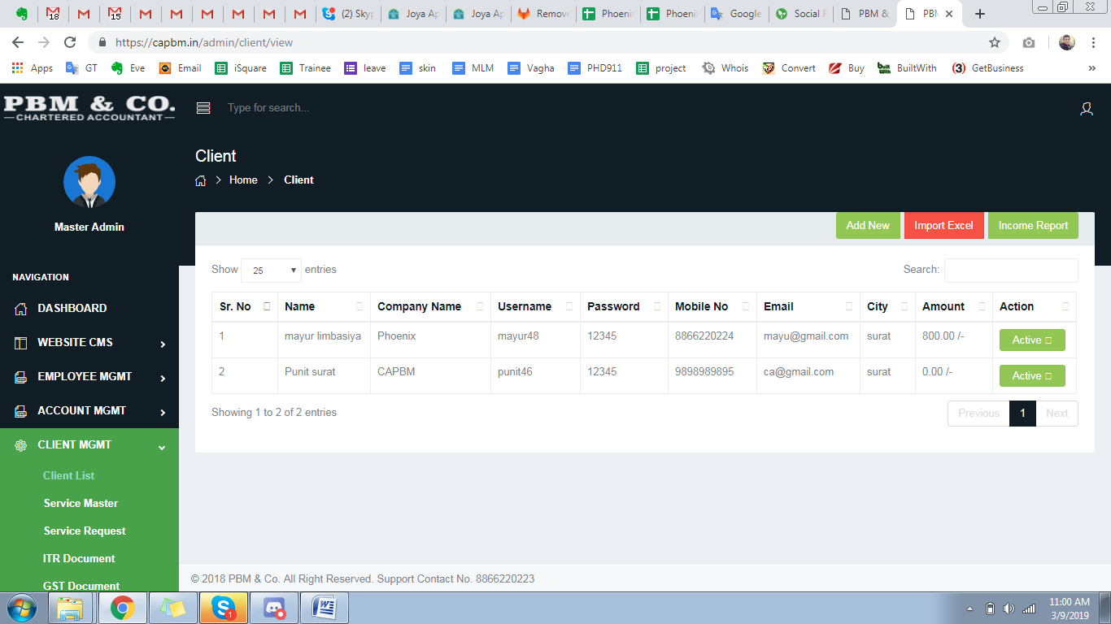

* Accountant ma add karvanu che (PACHI KARVU)

For example: accountant = ramjibhai

Teni niche 10 party che te potano badho data accountant login mathi add karse etle te master admin ne dekhase pachi te badha employee work devide kari dese..

* CA and Employee mate STICKY jevu kai thay sake je daily date and task name nakhi de etle te loko ne yad rahe tena mate
* Invoice ma “Autohirsed Signery” ni niche space rahe tem rakhvanu che..

