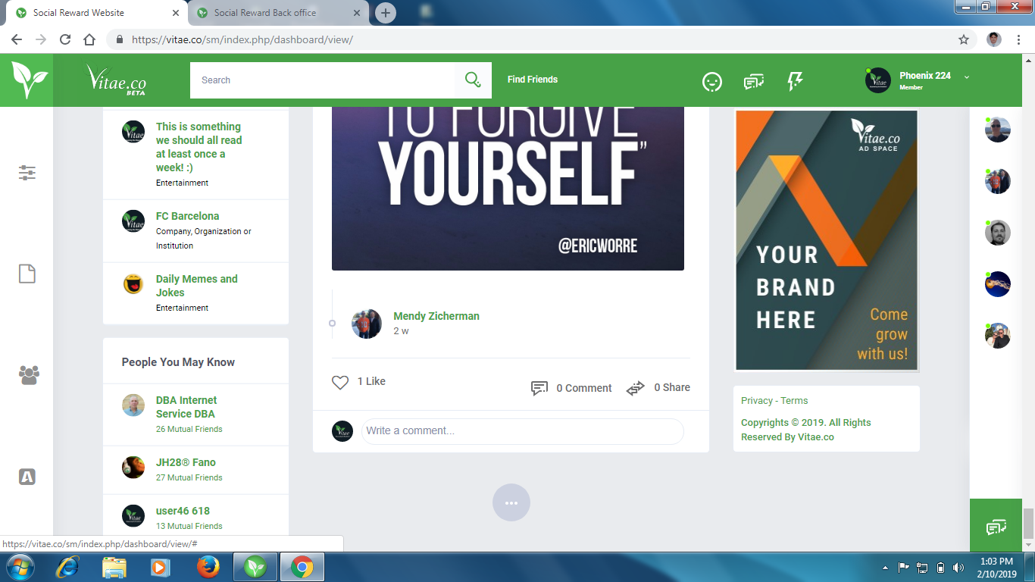

In above screen shot the page not drag down automatically when I click on the three dots icon then it load the down page .

2

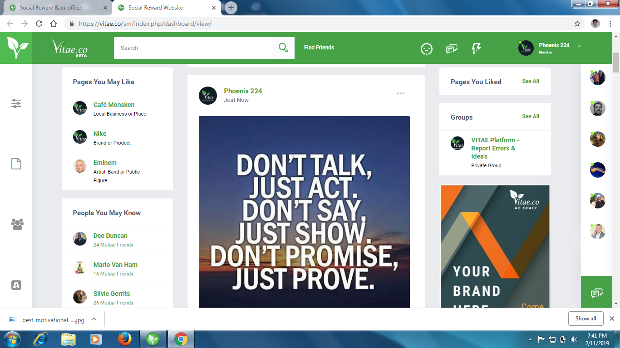

When I open any image on google & want t share from our website is not there, what the come is I mention below screen shot

3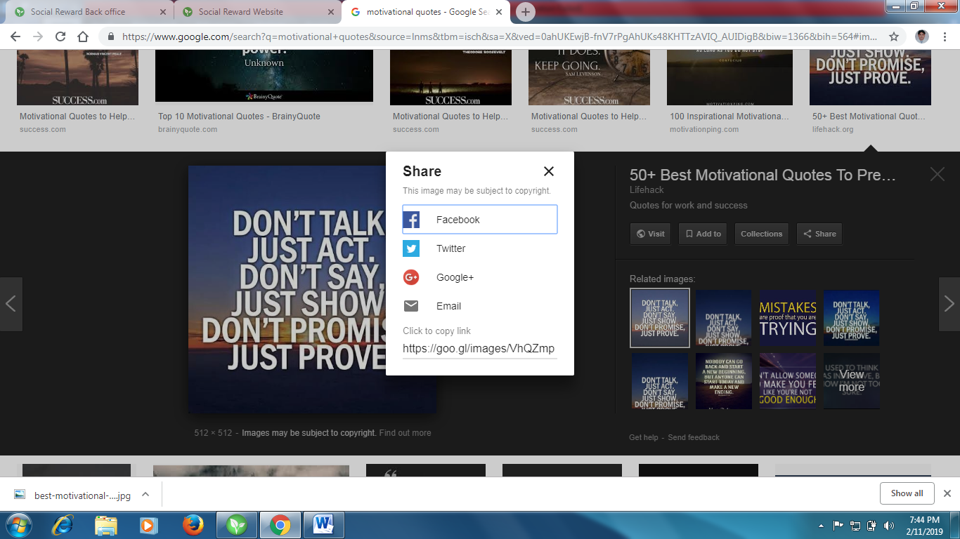

One thing more is there any option in our profile that who recently visit our profile or visitor profile pic like orkut .

4

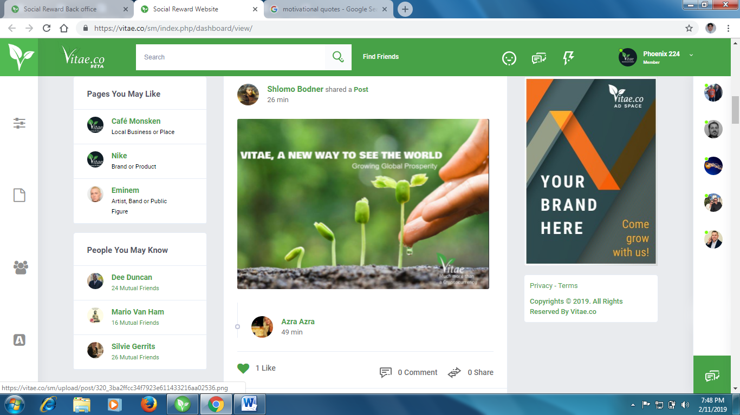

On this above image I like someone status & one like deduct from my account .