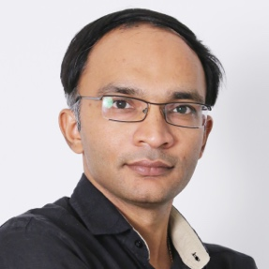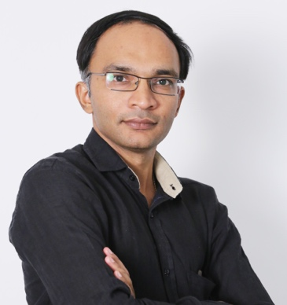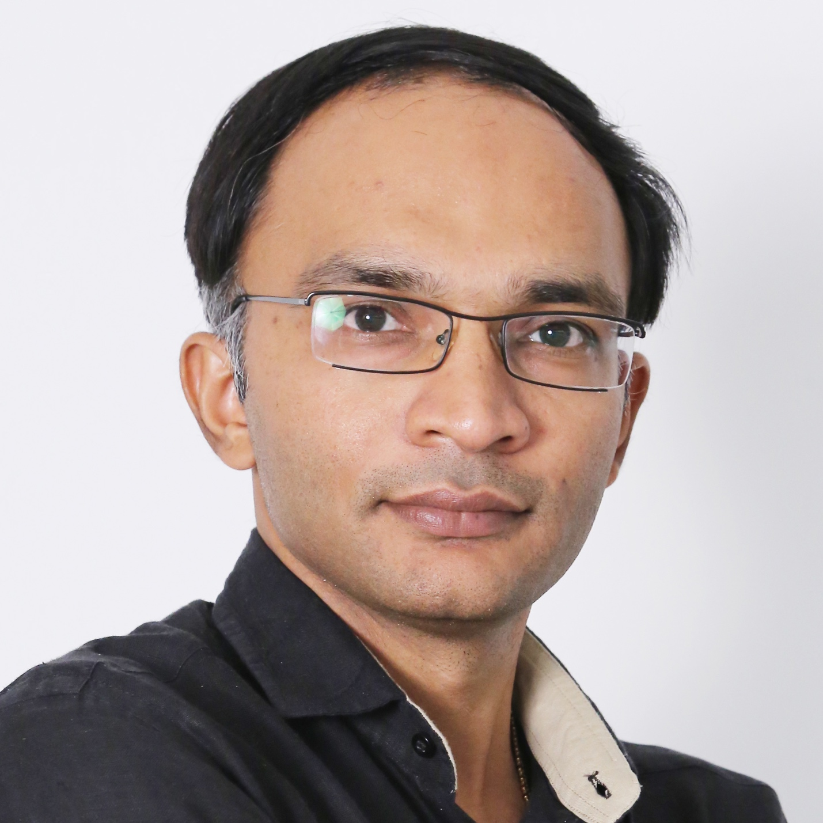

**EXPERIENCE**

Master Degree (2004-2015)

Best Programmer winner in university

Bachelor Degree (2000-2004)

UI/UX Design & Programming Knowledge.

**Creative Info way**

Creates graphics designs for the different websites worldwide. Follow up with establish customers to offer additional products or services.

**Phoenix Binary System Pvt. Ltd.**

I am expert with Laravel | Codeigniter | PHP | WordPress | HTML5 | JavaScript | CSS3 | Bootstrap | Web Services | Ajax | jQuery | Photoshop | Mongo DB MYSQL | SEO

**Sr. Graphic Designer**

2006 - 2010

Handle Crypto Projects | School Management System Mobility Service Provider | Manages IT services  
.

**Sardar Patel University**

**Bachelor in Software Engineer**

2000-2004

**Phoenix Binary System Pvt. Ltd.**

**PROGRAMMER | PROJECT HEAD**

**Mr. HITESH PATEL**

**EDUCATION**

**CONTACT**

**SKILLS**

**Project Head**

2014 - 2019

**Programmer**

2010 - 2014

**Master in E-Business**

2004-2005

**University of California**

**52-F Lincoln St. Mankato City,**

**Mankato**

**+91-8155-010-101**

**hiteshpatel8155@gmail.com**

**nickmichaels.com**

UI/UX

Photoshop

Illustrator

HTML

CSS